Electric Vehicles Market Size Analysis

Analyzing the market size for electric vehicles involves a series of steps that include outlining the market parameters, gathering and organizing

data, conducting analytical modeling, and presenting results through visualizations and reports.

**Data collection methodology** The data set has many data points such as county, city, state, postal code, model year, model, make, electric vehicle type, etc.

**Statistical and Analytic Issues** The dataset contains NA values in several columns, including county, city, postal code, legislative district, vehicle location, electric utility, and 2020 census tract, indicating that data for these fields is missing. As a result, we have excluded those rows with blank cells, which represent unavailable data.

# Data description of the data set of column

**Data Description**

VIN (1-10)

County City State

Postal Code Model Year Make Model

Electric Vehicle Type CAFV Eligibility Electric Range

Base MSRP Legislative District DOL Vehicle ID Vehicle Location Electric Utility 2020 Census Tract

This column consist of most of the countries of the world. The county in which the vehicle is registered.

The city in which the vehicle is registered.

The state in which the vehicle is registered. It appears that this dataset may be focused on Washington (WA) state.

The postal code where the vehicle is registered. The year of the vehicle model.

The manufacturer of the vehicle. The model of the vehicle.

The type of electric vehicle, e.g., Battery Electric Vehicle (BEV). Eligibility status for clean alternative fuel vehicle programs.

The maximum range of the vehicle on a single charge (in miles).

The Manufacturer’s Suggested Retail Price.

The legislative district where the vehicle is registered. Department of Licensing Vehicle Identification.

Geographic coordinates of the vehicle location.

The electric utility service provider for the vehicle’s location.

The census tract for the vehicle’s location.

# DATA VISUALIZATION AND ANALYSIS

We will be analyzing the data with the help of some questions. Below is the figure of the data sheet in excel that will give you the hint that how the data is available to us.

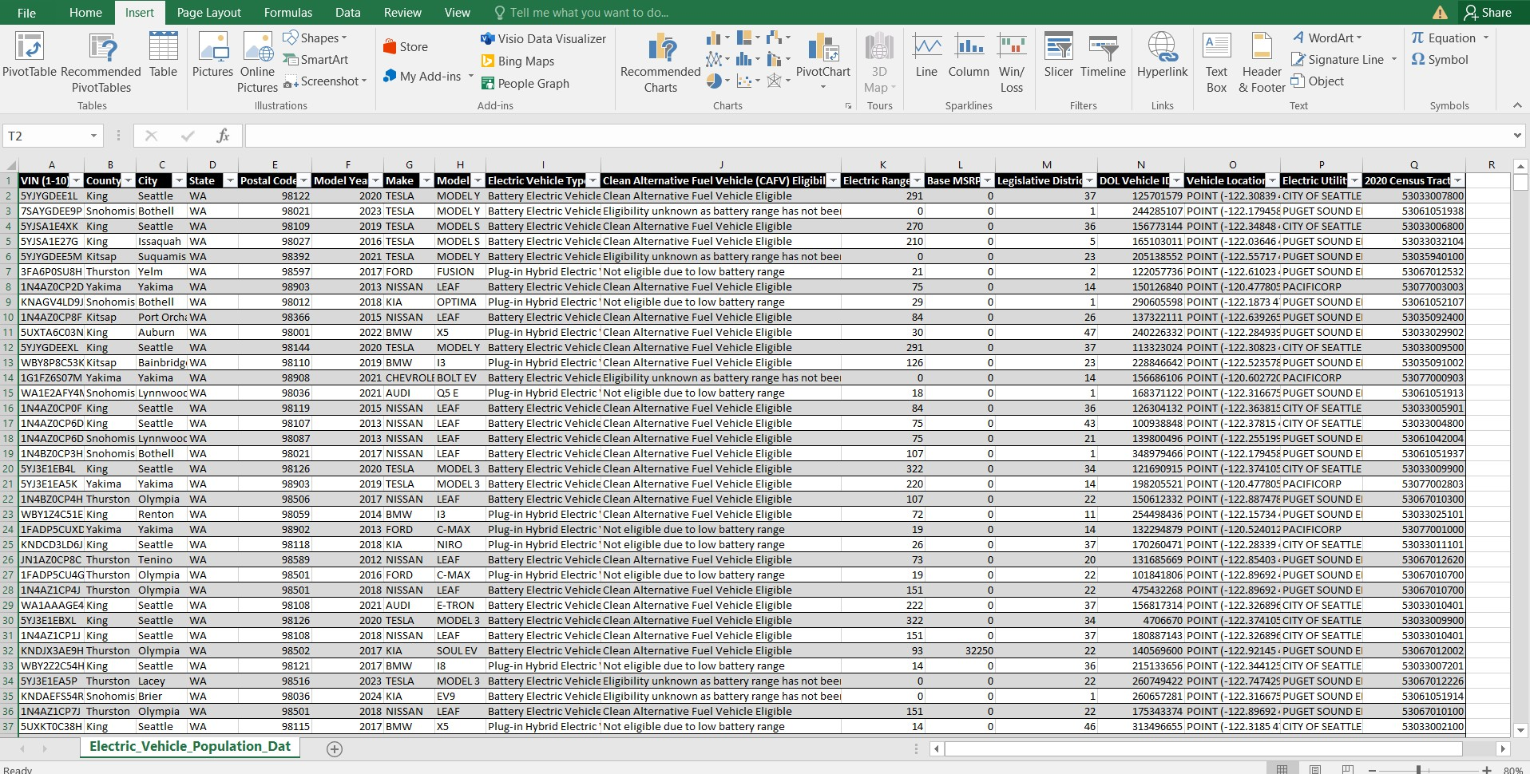

Figure 5.1: Electric Vehicles Population Dataset



Figure 5.2: Importing the required packages

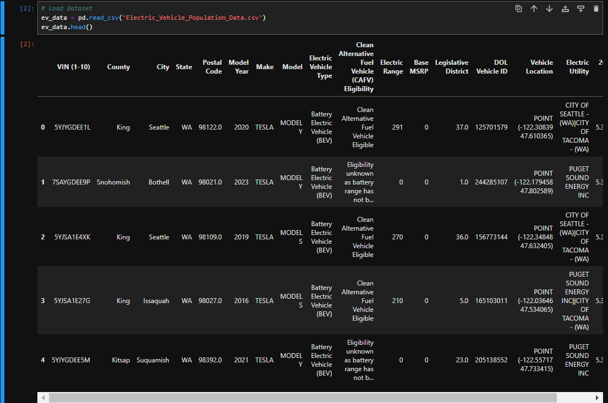

Figure 5.3: Reading the csv file



Figure 5.4: Dataset Information

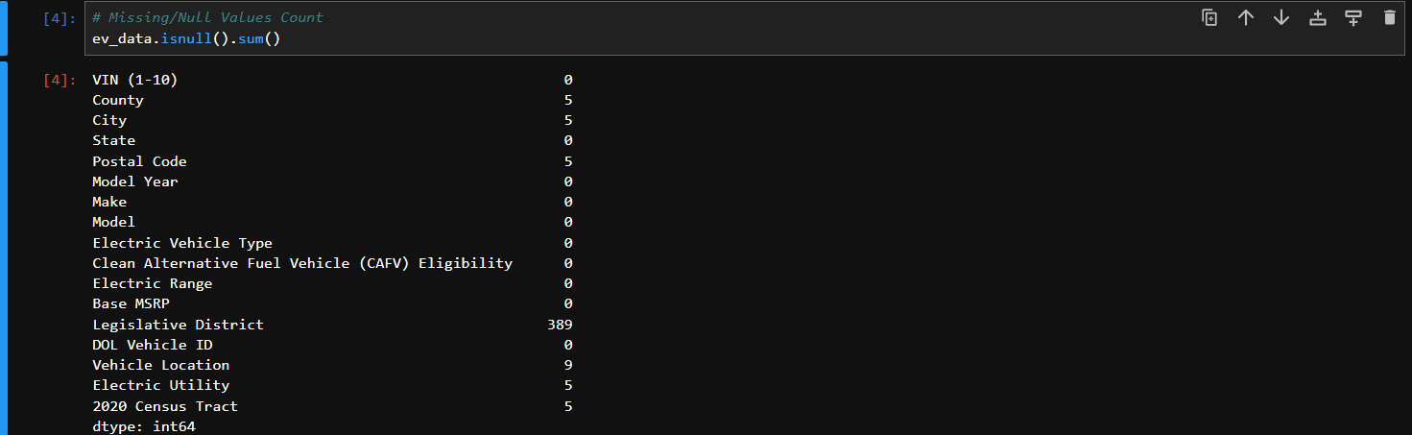

Figure 5.5: Missing/Null Values Count



Figure 5.6: Drop Null Values

1. Which counties have the highest concentration of vehicles in Washington state, and how does this distribution influence vehicle import trends, market preferences, and the demand for international vehicle brands?

**Solution:** Below code and figure will be useful for policy-makers, car manufacturers, and dealerships aiming to better understand the global composition of vehicles on the road in Washington.



Figure 5.7

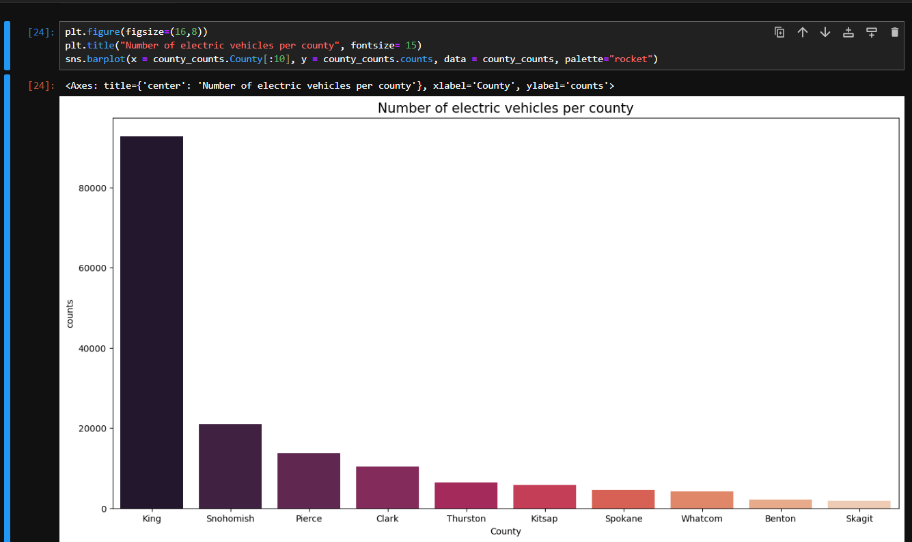

Figure 5.8

**Conclusion -** King County has the highest concentration of vehicles in Washington state, with 92,740 registered vehicles, making it the dominant region for vehicle ownership. Snohomish and Pierce counties follow with 21,001 and 13,782 vehicles, respectively, indicating that the Seattle metropolitan area is the primary hub for vehicle registrations. Clark and Thurston counties rank next, though their totals are significantly lower. The overall trend shows that urbanized counties have far higher vehicle concentrations compared to more rural regions like Benton and Skagit, reflecting population density and urban development patterns.

1. Which cities in Washington state have the highest concentration of registered vehicles, and how does this distribution impact local transportation infrastructure, environmental planning, and market potential for vehicle-related services?

**Solution:** Below code and figure will be useful for analyzing the vehicle registration data to identify the top 10 cities by vehicle count. This will provide key insights into areas with high vehicle concentration, enabling better planning for transportation infrastructure and services.



Figure 5.9

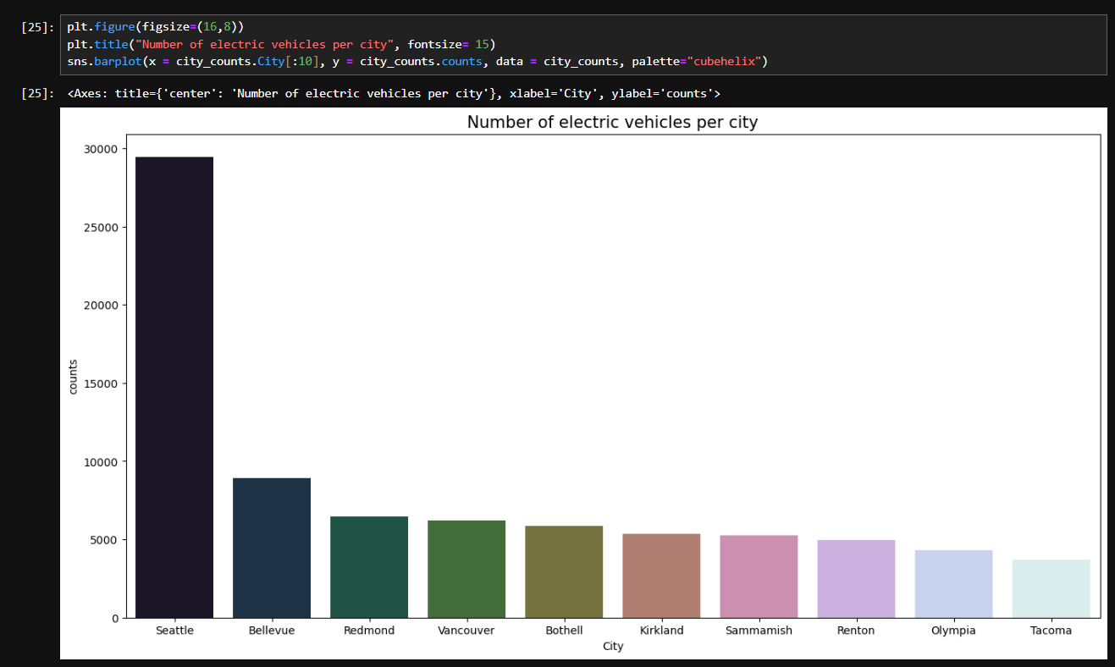

Figure 5.10

**Conclusion -** Seattle has the highest number of registered vehicles, with 29,447, significantly surpassing the other cities in Washington. Bellevue and Redmond follow, but with much lower counts, highlighting Seattle's dominance in vehicle registrations. The data suggests that urban areas, particularly those near tech hubs like Bellevue and Redmond, have a higher vehicle concentration, while cities like Olympia and Tacoma show a more moderate vehicle count.

1. How does the price of electric vehicles vary across different model years, and what factors contribute to these price fluctuations over time?

**Solution:** Below code and figure will be useful for analyzing how electric vehicle (EV) prices vary by model year to identify price trends over time. This analysis can help reveal factors like technological advancements, manufacturing costs, and market demand that impact EV pricing. It will assist manufacturers, consumers, and policymakers in understanding pricing patterns and making more informed decisions on EV adoption and incentives.

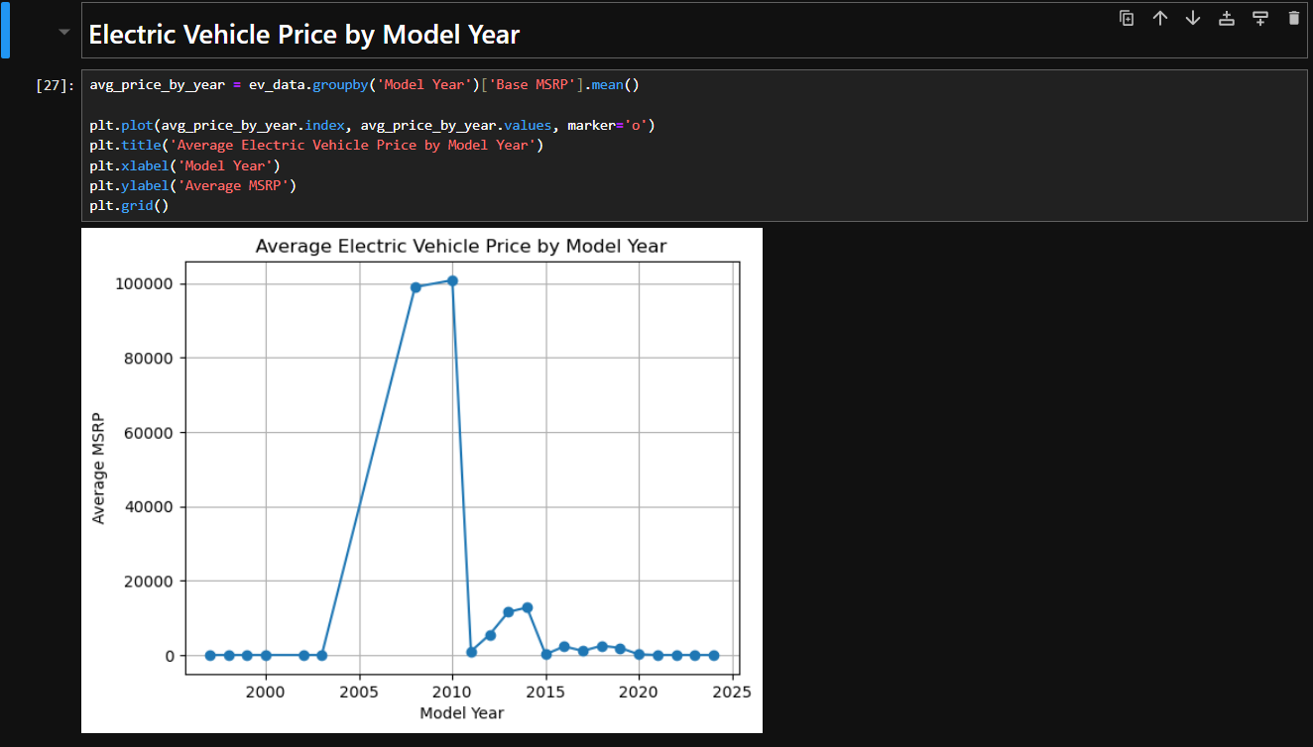

Figure 5.11

**Conclusion -** Early model years, particularly between 2008 and 2010, had significantly higher prices, with 2008 and 2010 models priced around $98,950 and $100,781, respectively. However, there is a sharp decline in prices for model years after 2011, with many years, including 2021-2024, having zero or minimal prices recorded. This suggests that older EVs were initially more expensive, and either prices have fallen significantly in recent years or the data lacks more recent vehicle prices.

4. Which vehicle types are most eligible for Clean Alternative Fuel Vehicle (CAFV) incentives, and how does this distribution affect the adoption of eco-friendly vehicles in different categories.

**Solution:** Below code and figure will be useful for analyzing increase the adoption of Clean Alternative Fuel Vehicles (CAFVs) across various vehicle categories, focus should be placed on promoting and incentivizing eligibility for diverse vehicle types, such as electric SUVs, trucks, and sedans. Policymakers and manufacturers can enhance awareness, offer incentives, and expand the range of eligible vehicles to encourage broader adoption and support the transition to cleaner, eco-friendly transportation.

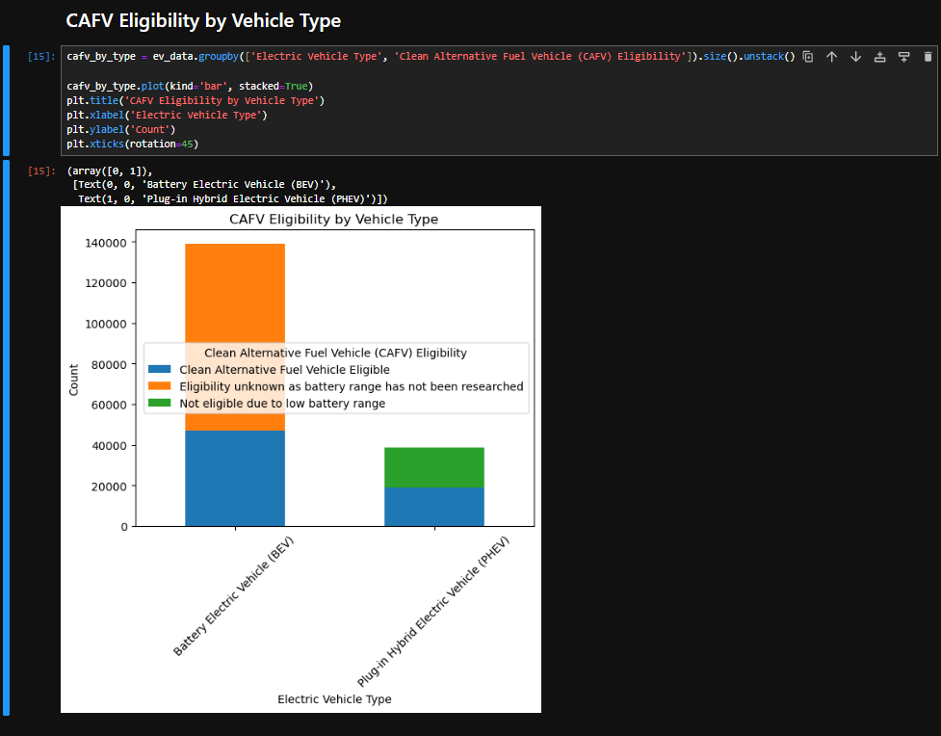

Figure 5.12

**Conclusion -** Clean Alternative Fuel Vehicle (CAFV) eligibility, we observe that a significant number of Battery Electric Vehicles (BEVs), 47,149, are eligible for CAFV incentives, while 91,790 BEVs have unknown eligibility due to unresearched battery range. Only a small portion (8 vehicles) is ineligible. In contrast, for Plug-in Hybrid Electric Vehicles (PHEVs), 19,017 are CAFV-eligible, but a considerable number, 19,509, are not eligible due to low battery range. This suggests that BEVs generally have better eligibility, though a large number of vehicles need further research on battery performance.

5. What are the differences in average electric range across various car manufacturers, and how do these variations impact consumer preferences for electric vehicles?

**Solution:** Below code and figure will be useful for analyzing electric range varies significantly across different car manufacturers. Brands with higher average electric ranges may attract more consumers due to the longer driving distance on a single charge, which is a key factor in electric vehicle (EV) adoption. Manufacturers with lower ranges might need to focus on improving battery efficiency or targeting specific markets where range is less of a priority. By analyzing these ranges, manufacturers can optimize their product offerings to align with market demands for longer-range electric vehicles.

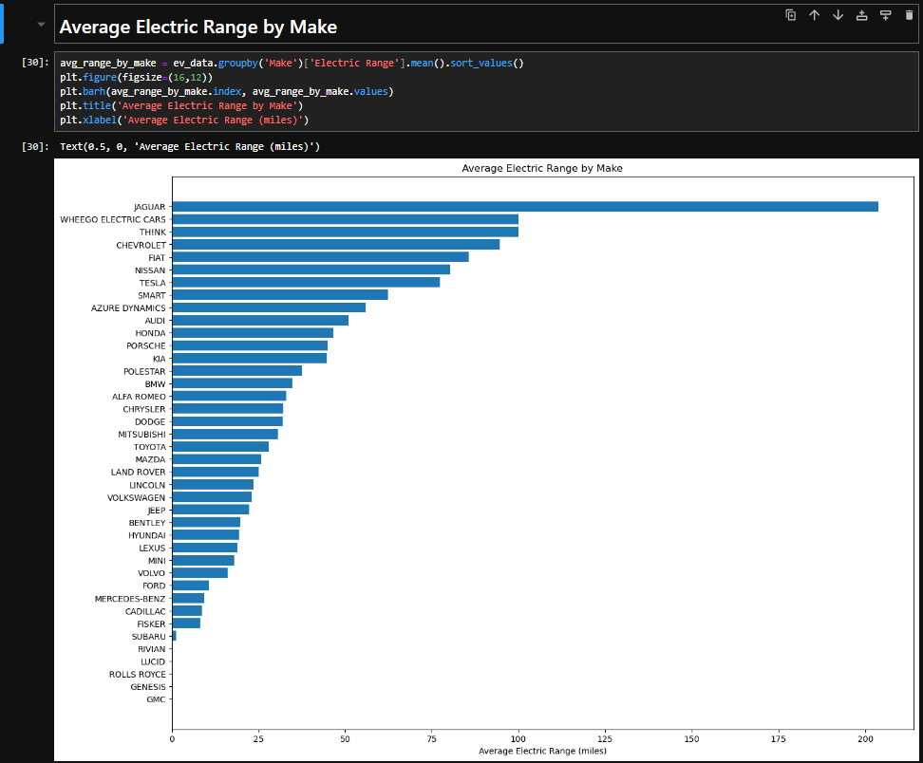

Figure 5.13

**Conclusion -** average electric range by make reveals significant variation among manufacturers. Brands like Jaguar, with an exceptionally high average range of over 200 miles, and Tesla, with over 77 miles, lead the market in terms of electric vehicle range. Conversely, luxury and high-performance brands like Rolls Royce, Lucid, and GMC show zero or near-zero electric range, indicating their minimal focus on electric vehicles. This insight highlights that certain manufacturers, especially luxury brands, may still have limited offerings in the EV market, while others, particularly Tesla, Nissan, and Chevrolet, are prioritizing long-range electric vehicles.

6. What is the trend in electric vehicle (EV) registration growth over the years, and which years have seen the highest or lowest growth rates?

**Solution:** Below code and figure will be useful for analyzing the "EV Registration Growth Rate by Year" insight involves calculating the year-over-year percentage growth in EV registrations. This will highlight trends such as periods of rapid growth, steady increases, or stagnation.

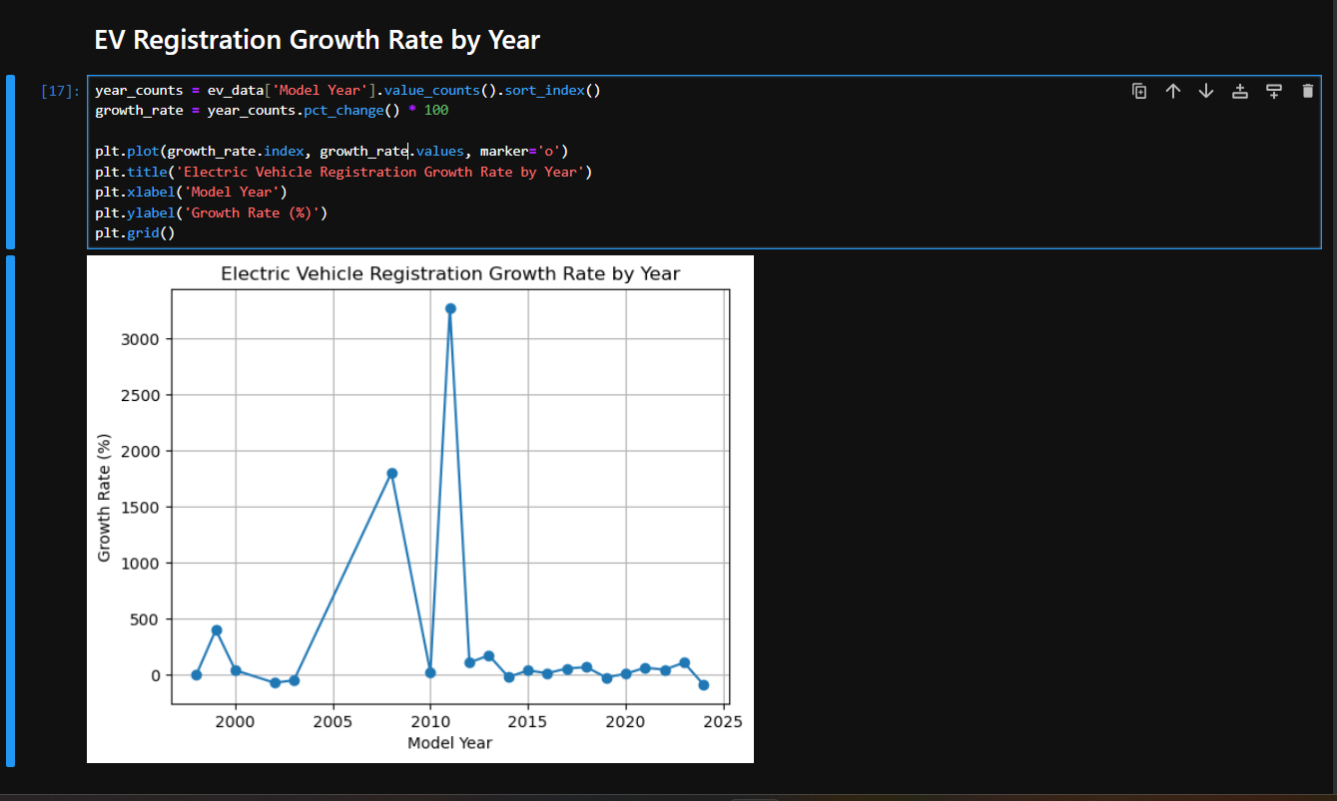  
  
 Figure 5.14

**Conclusion -** Steady increase in electric vehicle (EV) registrations from 1997 to 2023, with significant growth observed after 2010. The most notable surge occurred in 2023, with a 107.6% increase in registrations, indicating a rapid acceleration in EV adoption. However, the registration growth dropped sharply by 87.7% in 2024, suggesting either market saturation, a supply chain issue, or changes in EV policies. Overall, the trend reveals a strong upward trajectory in EV adoption, but with some fluctuations that merit further investigation to understand the causes behind the 2024 decline.

7. How does the average Manufacturer's Suggested Retail Price (MSRP) vary between different types of electric vehicles (e.g., Battery Electric Vehicles vs. Plug-in Hybrid Electric Vehicles)?

**Solution:** Below code and figure will be useful for analyzing the differences in average MSRP between various electric vehicle types, such as Battery Electric Vehicles (BEVs) and Plug-in Hybrid Electric Vehicles (PHEVs). This comparison provides insights into the pricing trends, helping consumers and manufacturers understand which type of EV offers more value for the price.

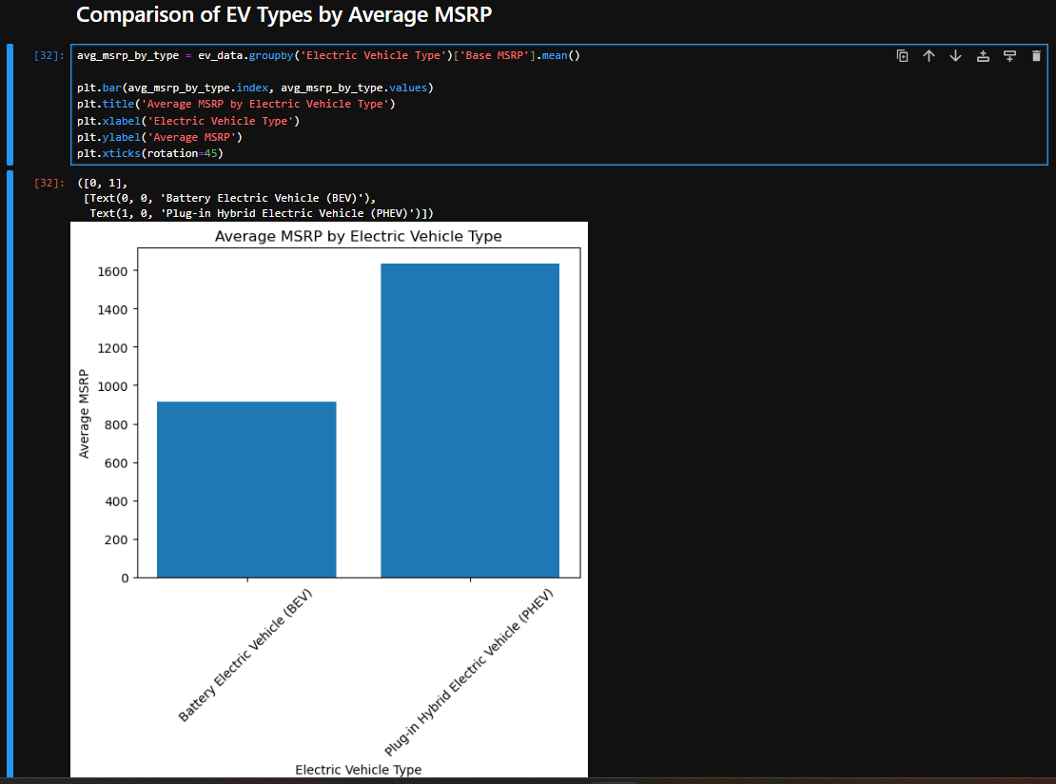

Figure 5.15

**Conclusion -** comparison of average MSRP by electric vehicle type shows that **Plug-in Hybrid Electric Vehicles (PHEVs) have a significantly higher average MSRP (1,632.99 units) compared to Battery Electric Vehicles (BEVs), which have an average MSRP of 914.68 units.** This suggests that PHEVs are generally more expensive than BEVs, potentially due to the additional hybrid technology they incorporate, offering both electric and fuel options.

8. How has the adoption rate of electric vehicles changed over time, and what factors have influenced significant increases or decreases in specific years?

**Solution:** Below code and figure will be useful for analyzing the adoption rate of electric vehicles has shown significant growth, particularly in recent years. This upward trend is driven by advancements in EV technology, increasing environmental awareness, and supportive government policies. Addressing infrastructure challenges, such as expanding charging networks, and offering incentives can further accelerate this growth in the coming years.

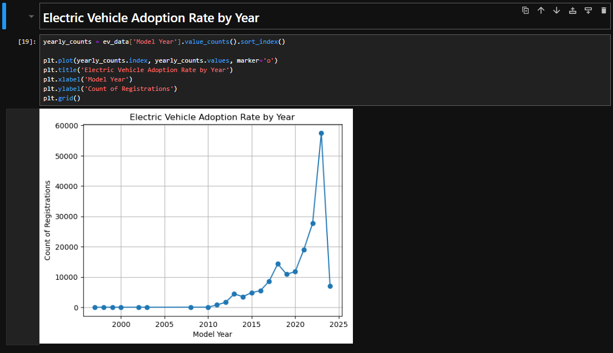

Figure 5.16

**Conclusion -** Electric vehicle (EV) registrations by model year shows a clear upward trend in EV adoption, with significant growth starting in 2011. This trend accelerates in the 2020s, reaching a peak of 57,519 registrations in 2023. The sharp rise in recent years reflects increasing consumer interest in EVs, likely driven by technological advancements, broader availability, and growing environmental concerns. However, the lower number in 2024 (7,072) may suggest that more data or market factors need to be considered to understand if this drop is temporary or part of a larger trend.

9. How does the electric range of Battery Electric Vehicles (BEVs) compare to that of Plug-in Hybrid Electric Vehicles (PHEVs), and what factors contribute to the differences in range?

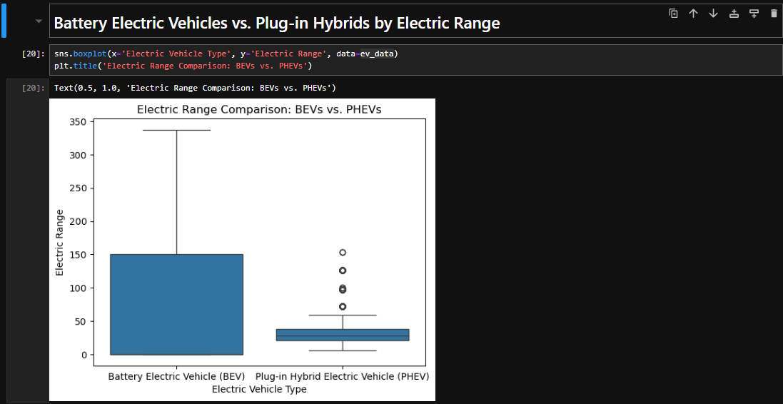

Figure 5.17

10. How does the average electric range across different vehicle type?

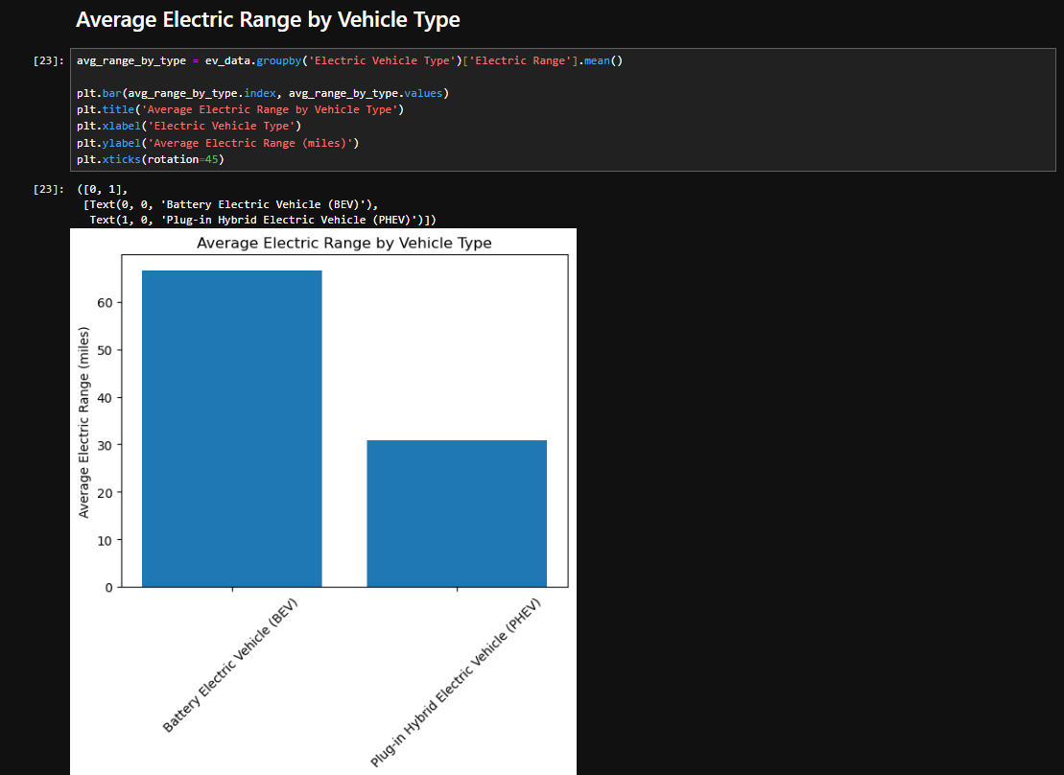

Figure 5.18

**Conclusion –** Average electric range of Battery Electric Vehicle is higher compare to Plug-in Hybrid Electric Vehicle. Average electric range of BEV is 65 to 67 and PHEV electric range is 30.